**PYTHON CLASS - 3**

Q1. Find the Armstrong Number between the two numbers which are input by user

Armstrong number: 153 -> 1*1*1 + 5*5*5 + 3*3*3

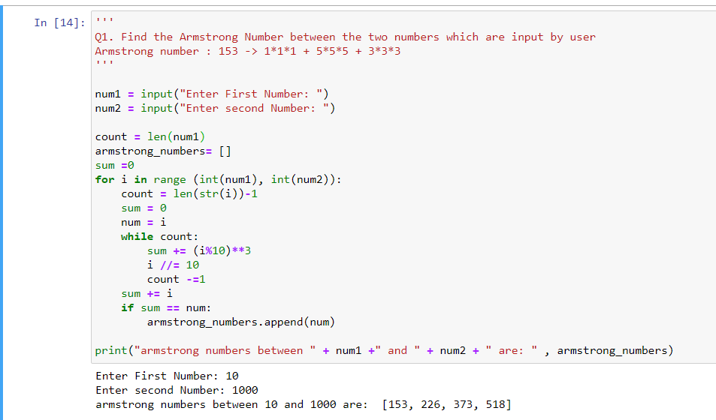

Q2. Let’s say you have a string “hello this world @2020!!! ”

* Remove the punctuation like [“@!#$%&*()”] from the string
* Final output should be without the punctuation
* “hello this world 2020”

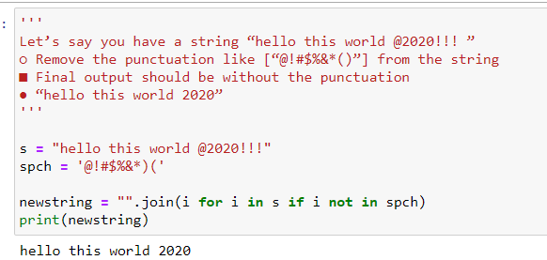

Q3. You have a list with words - [“Apple”, “banana”, “cat”, “REGEX”,”apple”]

* Sort words in Alphabetical order
* If you get output, like [Apple, apple, banana]
* How has it happened?

